If object has any numerical variable as it’s data member than we can compare two objects

Which also means we can actually sort two objects based on that numerical value

In java we are given with a Comparable interface for this

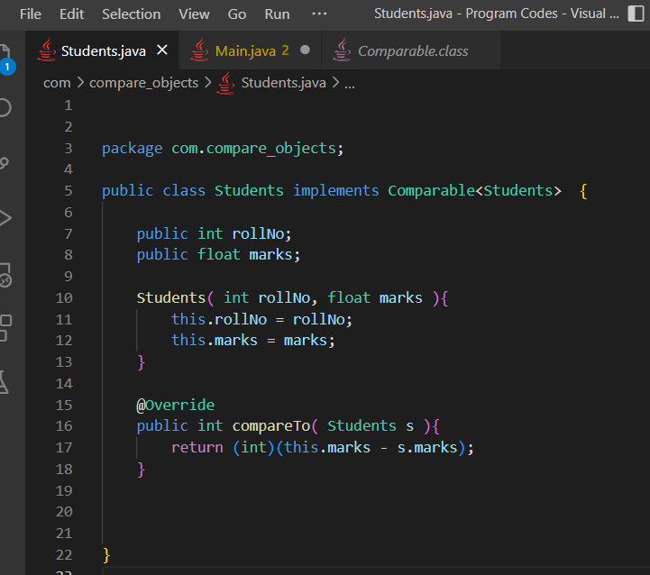

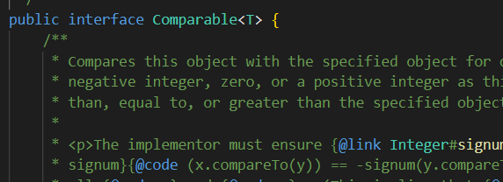

The comparable interface is actually using generic, so we provided <Students> while extending

This interface contains compareTo( ) method which we can override and define as per our need like we did in Students.java class above

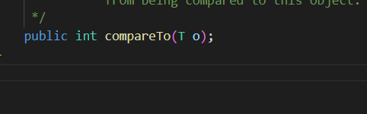

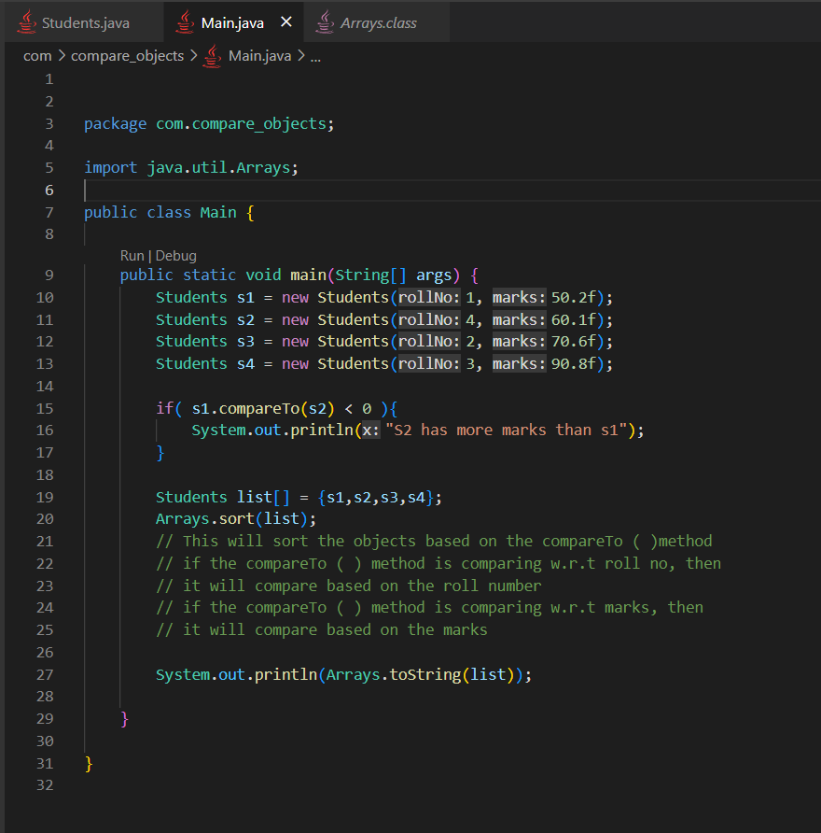

Actually this is not the best practice

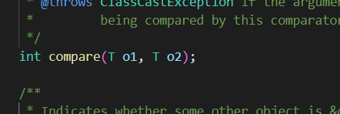

In comparator interface compare( ) method is available, which we could use inside the Array.sort( ) method to compare the items

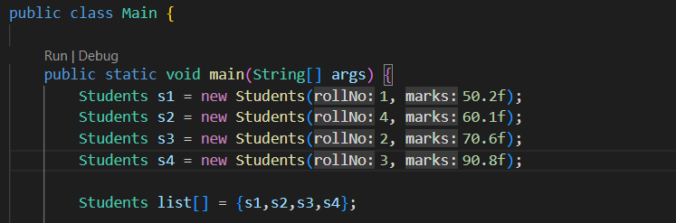

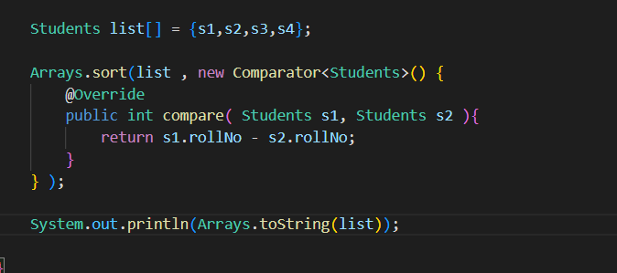

Since every single primitive data types also has their object equivalent in java, like

Int == Integer

float == Float

So, we can use this for Integer, Float and other also

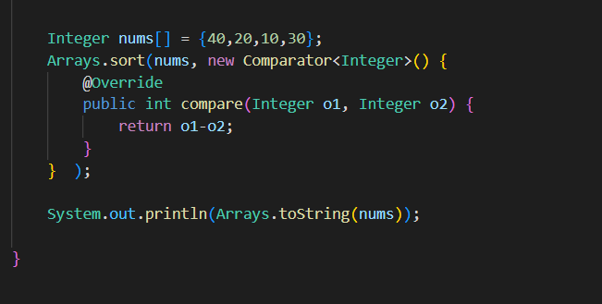

Let say we want to sort in descending order

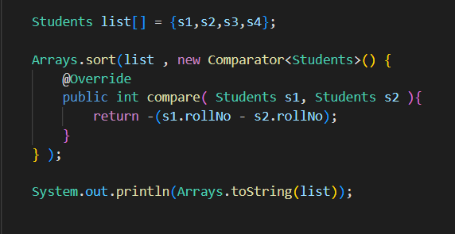

Just add the “-“ while returning

